ACTIVITY REPORT
Attendance:
___8___ members
___3___ non-members
___1___ staff
_______ invited guests
Organizer : UTAR Yoga Society . __________
Activity Name : Yoga Free trial class 2025 FEB session___________
Date : 26 FEB 2025 (Thursday)_______________________
Time : 6:30 pm – 7:30 pm___________________________
Venue : Performing Arts Studio (KB111 & KB112), Sungai___
Long Campus.

Reported by:

____________ _____SECRETARY_______ _1 MARCH 2026__
(Susie)LIM SAIKEAT Designation Date

DESCRIPTION OF THE ACTIVITY
- Executive Summary
The Yoga Free Trial Classes 2026 – Feb Session were organized by UTAR Yoga Society as a wellness-focused, introductory multi-level yoga activity for UTAR students, especially with particular emphasis on Feb 2025 intake freshmen.

The overall atmosphere was relaxed and friendly, with a good response from freshmen and some ordinary members choosing to join or re-engage with the club after the sessions. The main achievement was providing free access to yoga using mats supplied by society, giving non-members a safe opportunity to experience yoga, supporting student wellbeing and stress relief, and cultivating interest for future membership and regular classes.

Session | Date | Time | Estimated Registered | Estimated Attended | Remarks
1 | 26 Feb 2025 (Thu) | 6:30–7:30 pm | ~8 | ~11 | Smaller but engaged group
Across both sessions, there were a few new registered members (approx. 2–5) and additional participants whose interest was cultivated for future activities. Most participants were not complete beginners, but several had not practiced yoga for a long time and used this event to restart.

- Outcome
2.1 Activity progress for Both sessions flow:
1. Arrival and mat arrangement
2. Brief introduction and safety reminder
3. Gentle warm-up and joint mobilization
4. Multi-level yoga practice (standing, seated and simple balancing postures)
5. Cool-down, light stretching and simple breathing/relaxation
6. Closing reflection and sharing about future classes
Feedback form participance:
- The instructor engaged participants by asking about their experience of multi-level yoga, feelings of relaxation, and interest in other types of yoga or refresher sessions.
- Participants reported benefits such as muscle and back tension release and a sense of distress after class.

2.2 Outcome of the activity
Indicative outcomes:
- New registered members from the activity: approximately 2–5.
- Participants who expressed interest in future yoga classes or membership
- Several participants noted back pain relief and muscle distress and expressed appreciation for the free opportunity to join.

Overall, the activity contributed positively to the campus wellbeing environment and provided a concrete platform for membership drive and community building for UTAR Yoga Society.
26 FEB Attendance
ID | CLASSES | STATUS | NAME | EMAIL | ROLE
2400998 | 26 FEB- Free Trial (6:00 pm - 7:30 pm) | OK (IN+OUT) | Avril Loong Cho Yii | avrilloong04@1utar.my | Student- Non-member
2402969 | 26 FEB- Free Trial (6:00 pm - 7:30 pm) | OK (IN+OUT) | Iviana Chong Shu Ping | ivianachong060612@1utar.my | Student- Non-member
2204963 | 26 FEB- Free Trial (6:00 pm - 7:30 pm) | OK (IN+OUT) | Joey Low Hui Sun | leiyuannn@1utar.my | Student- Non-member
2203464 | 26 FEB- Free Trial (6:00 pm - 7:30 pm) | OK (IN+OUT) | Lam Mun E | pen9mune@1utar.my | Student- Member
2504365 | 26 FEB- Free Trial (6:00 pm - 7:30 pm) | OK (IN+OUT) | Lim Sai Keat | susie.limsk2025@1utar.my | Student- Member
E16011 | 26 FEB- Free Trial (6:00 pm - 7:30 pm) | OK (IN+OUT) | Liu Dan | liudan@utar.edu.my | Staff
2401177 | 26 FEB- Free Trial (6:00 pm - 7:30 pm) | OK (IN+OUT) | Michelle Sim Qian Yi | 0920michelle@1utar.my | Student- Member
2501415 | 26 FEB- Free Trial (6:00 pm - 7:30 pm) | OK (IN+OUT) | Poh Kai Xin | pohkaixin0317@1utar.my | Student- Member
2207210 | 26 FEB- Free Trial (6:00 pm - 7:30 pm) | OK (IN+OUT) | Pong En Ni | anny1216@1utar.my | Student- Member
2401815 | 26 FEB- Free Trial (6:00 pm - 7:30 pm) | OK (IN+OUT) | Song Jian Jian | jsong2006@1utar.my | Student-Member
2401886 | 26 FEB- Free Trial (6:00 pm - 7:30 pm) | OK (IN+OUT) | Tan Xiao Xuan | xxtan0406@1utar.my | Student-Member
2600645 | 26 FEB- Free Trial (6:00 pm - 7:30 pm) | OUT only | liu xie.xuan |  | 2600645

- Conclusion
Overall, the event can be rated meeting expectations, as it successfully provided a free and accessible stress-relief activity after class, attracted a positive response from freshmen and returning members, and created a relaxed, friendly atmosphere where participants interacted well with both the instructor and the committee. Many participants reported physical benefits such as relaxation, backpain relief and muscle tension release, indicating that the wellbeing objective was met. However, the number of new members recruited was lower than hoped for a short semester, the multi-level class format proved challenging for some participants, and the venue felt slightly crowded at higher turnout, suggesting the need for clearer level segmentation and better pre-registration control in future. Moving forward, the society plans to continue promoting yoga as a casual weekly activity open to all UTAR students, maintaining a clear focus on wellness and stress relief rather than income.

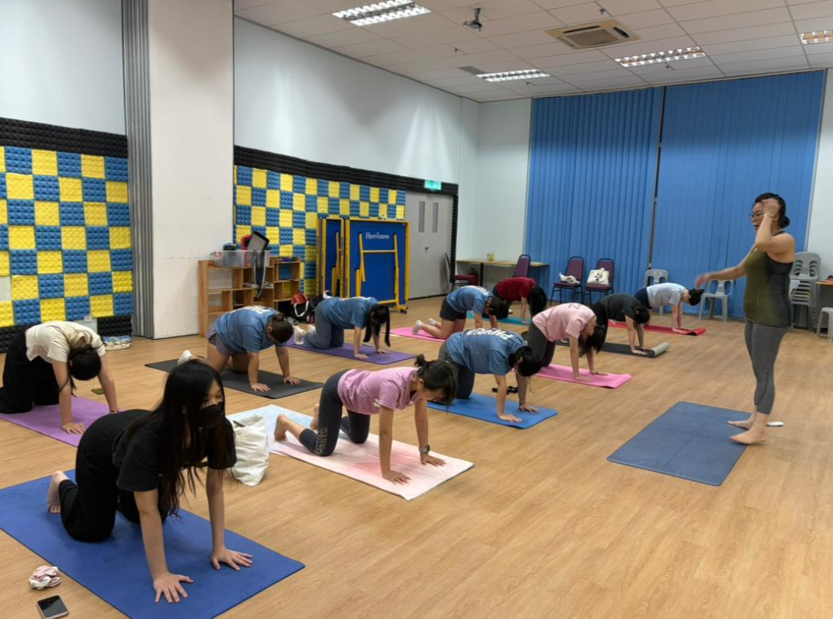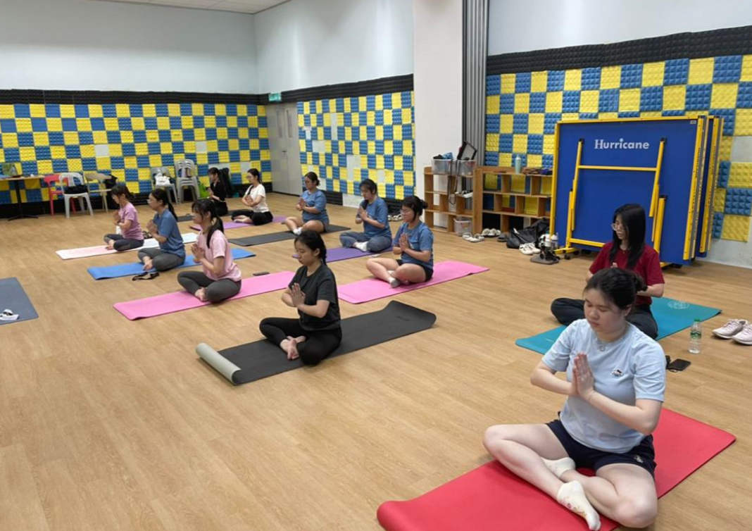

26 Feb 2026 6:50PM – Free trial class

